Subject Line: Magellan Bulletin - July 2022 Momentum Engagement Campaign and Webinars
Email content is below.

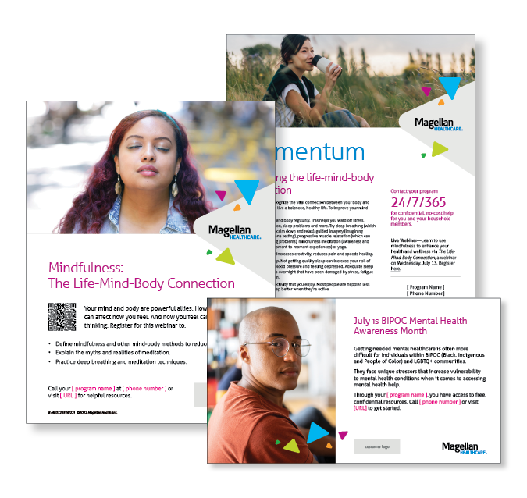
Monthly Theme – Employees
Improving the life-mind-body connection
It’s important to recognize the vital connection between your body and mind if you want to live a balanced, healthy life. Learn how to improve your mind-body health in this month’s newsletter.

Monthly Webinar – Employees
The Life-Mind-Body Connection | July 13
Join this webinar to:
- Define mindfulness and other mind-body methods to reduce stress.
- Explain the myths and realities of meditation.
- Practice deep breathing and meditation techniques.
Register here

Financial Wellness Monthly Webinars
Balancing Your Financial & Emotional Wellbeing | July 12
Register here: 9 am PT | 12 pm PT
Financial stress often goes hand in hand with emotional strains. Review common financial and emotional challenges and get tips for managing them. Also learn how working with professionals can help.

Investing: Education for Beginners | July 28
Register here: 9 am PT | 12 pm PT
Learn how certain investment accounts and timeframes can help you reach your long-term savings goals. Review how mutual funds, stocks, bonds and other investments work. Conclude with practical action steps you can take.

