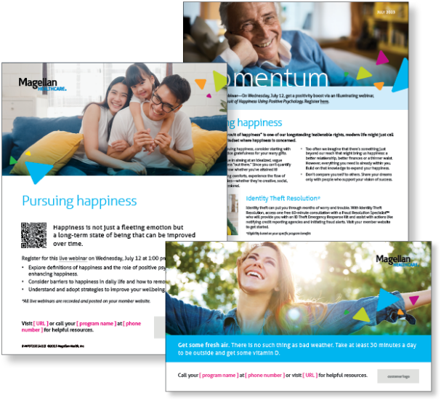
Subject Line: Magellan Bulletin – July 2023 Momentum Engagement Campaign and Webinars
Email content is below.

Monthly Theme
Pursuing happiness
Although “the pursuit of happiness” is one of our longstanding inalienable rights, modern life might just call
for an updated mindset where happiness is concerned. Learn more in this month’s newsletter.

Monthly Webinar
The Pursuit of Happiness Using Positive Psychology | July 12
Join this webinar to:
- Define happiness and the role of positive psychology
- Discuss barriers to happiness
- Practice strategies to improve your wellbeing
Register here

Financial Wellbeing Monthly Webinars
Student Loan Repayment Strategies | July 11
Register here: 9 am PT | 12 pm PT
For many employees, especially in the first half of their careers, student loan payments are a significant monthly expense. This class helps attendees consider repayment options that meet their individual goals. We discuss repayment options and explain forgiveness programs. We will also include how you might lower monthly payments or pay off loans faster.

Investing: Risk Considerations & Taxes
Register here: 9 am PT | 12 pm PT
This class reviews five types of investment risk. It also explores how time frames and your investment profile might influence investments you are willing to consider. We’ll cover some tax implications of investing and conclude with investment examples and possible risks. We will also outline action steps for those who wish to learn more.

